Sources for the family of my great-great grandfather*,
Michael Britt** Kelly in Ireland and Iowa.
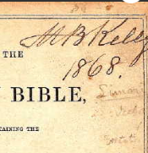
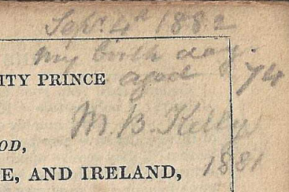
Birth:
*Written, researched, and compiled by Dana Sue Kelley Bressette

Notations from his bible suggesting his birthday, Sep 4, 1808, Limerick, Ireland

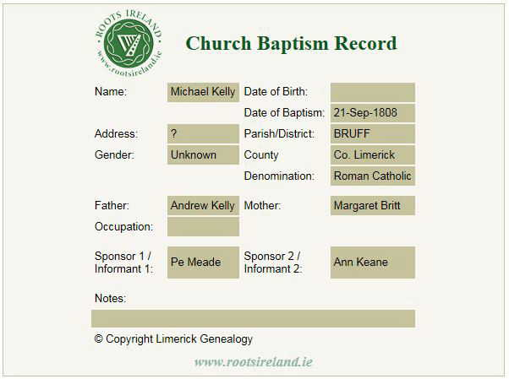
Baptism:
Since Kelly is a common name, a cousin once questioned whether this baptism record was actually for our great -great grandfather. But I am confident that it is, given what I have learned about Irish naming patterns…see references on page 13…

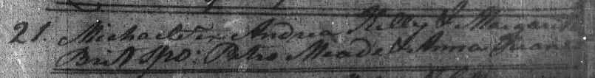
Catholic Parish Registers of Bruff, Grange and Gilnogra | Microfilm 02428 / 08
**We had previously thought Michael’s middle name was Brett, but after finding the above record, I found that a grandson’s middle name was also Britt…I have found in the course of my research that vowels often seem to be interchangeable in Ireland! ---There was a Thomas Brett, a mathematician/teacher listed in Bruff in 1787, possibly his grandfather?
**I have found a few records for Andrew Kelly or O’Kelly in Bruff & Limerick County…It is hard to determine whether all or any refer to Michael’s father:
Andrew O’Kelly & wife Margaret, Public House Keeper, Bruff 1801, Journal of the House of Lords, court proceedings.
Andrew O’Kelly, Schoolmaster, R. catholic 1826, Bruff.
Andrew Kelly, Ballyshonikin, Effin, Limerick, 1829-1853, Tithe Applotment Books, Griffith’ s Evaluation
Andrew Kelly, Death Record: 6 Jun 1866, Age: 90, Nelson St. Limerick, Occupation: Victualler, Informant: Michael Kelly

Marriage of Michael B. Kelly to Mary McKettrick:
Note: The first source we found for the maiden name of Michael’s wife was in a marriage register for my great grandfather, Andrew A. Kelley (see below). Her name was originally mistakenly transcribed as “Maceltrick” instead of “Macettrick.” Other sources have various spellings of the name: McKettrick, McKitterick, McKetterick.

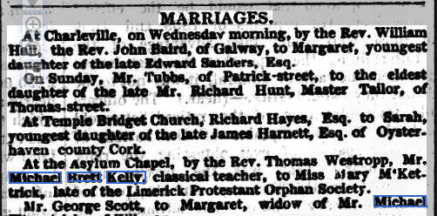

Limerick Chronicle - Wednesday 22 May 1844
(A Facebook reply on a post suggested that it would have been unlikely for a Classical Teacher to marry an orphan due to class differences, but all the previous notices list the fathers of the brides???)
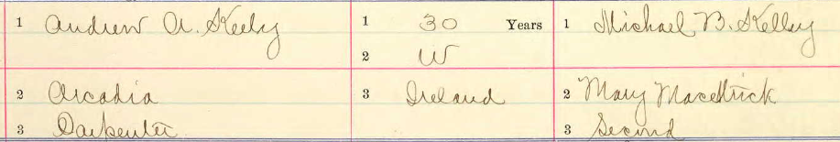
Iowa, U.S., Marriage Records, 1880-1947, 1881 > 300 (Adair - Cedar)
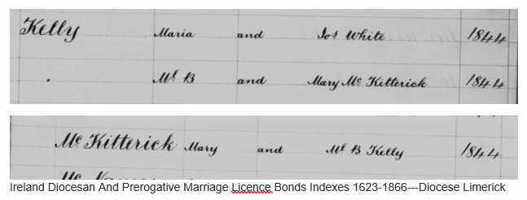

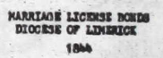
Ireland, Casey Collection Indexes, 1545-1960 Volume 08: Historical and Genealogical Items Relating to North Cork and East Kerry
Ireland, Casey Collection Indexes, 1545-1960, Volume 08: Historical and Genealogical Items Relating to North Cork and East Kerry

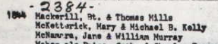
Known Children:
- Margaret Kelly, born in Kinnitty, Kings Co, [24] Feb 1845, as per her confirmation certificate, see later.
- Zillah Kelly, born in Beigh Askeaton, Co. Limerick, January 3, 1849, as per her confirmation certificate, see later.
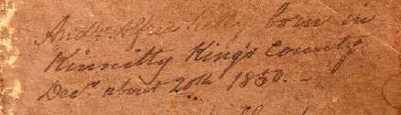
- Andrew Alfred Kelly, born in Kinnitty, King’s County, Dec about 20th [family records: 24th] 1850, according to entry in his father’s bible:

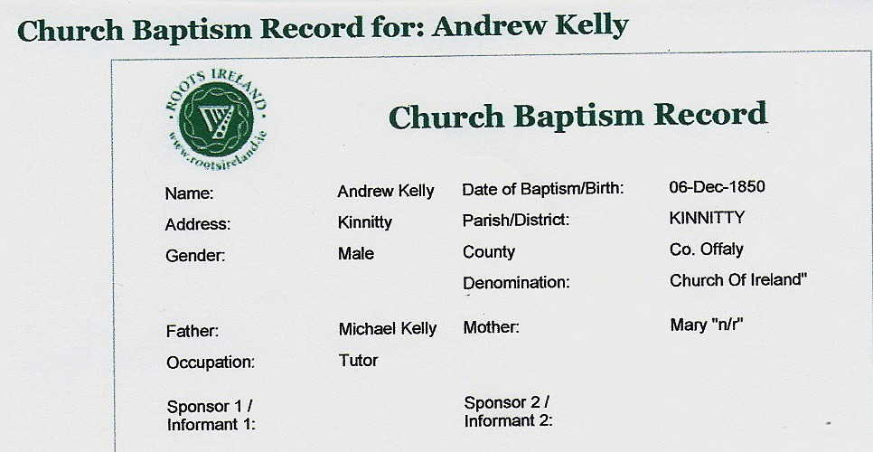
Date of Baptism given as 06 Dec 1850---possible transcription error?—I keep hoping that they will release scanned copies of original documents!

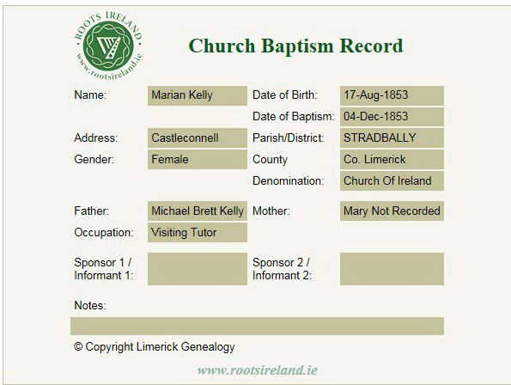
- Marion Kelly, Baptized 17 Aug 1853, Castleconnell, Stradbally Parish, Co. Limerick-- previously unknown child, but I found the following record:

Michael Britt Kelly family, Residences/source locations:
The family seemed to fare well enough through the famine years (1845-52). That is when all the children were born!
- Sep 1808, Bruff, Limerick Co. Birth/Baptism
- Where did Michael go to college?
- May 1844, City of Limerick, Marriage at “Asylum” Chapel, Age 35.
- Feb 1845, Kinnitty, Kings Co., Birth of daughter, Margaret
- Jan 1849, Beigh Askeaton, Birth of daughter, Zillah
- Dec 1850, Kinnitty, Kings Co., Birth of son, Andrew, Occupation: Tutor
- 1851? Beagh, Iveruss, Limerick, Ireland, Griffith’s Valuation 1848-1864 & Ireland Valuation Record 1824-1856
- Aug 1853, Castleconnell, Limerick Co., Birth of daughter Marian, Occupation: Visiting tutor
- Aug 1863, Ballymullan Tralee, Kerry Co. his daughter’s confirmation certificates.
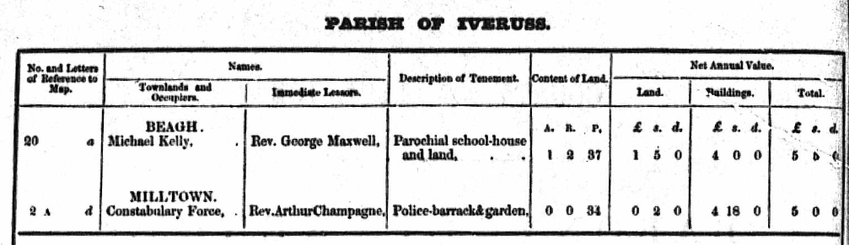
- 1870-1885, Clinton, Iowa, U.S.A. City directories, 1885 census, & Death Record.
Ireland, Index to Griffith’s Valuation, 1848-1864
See map next page for location of 20a on map.
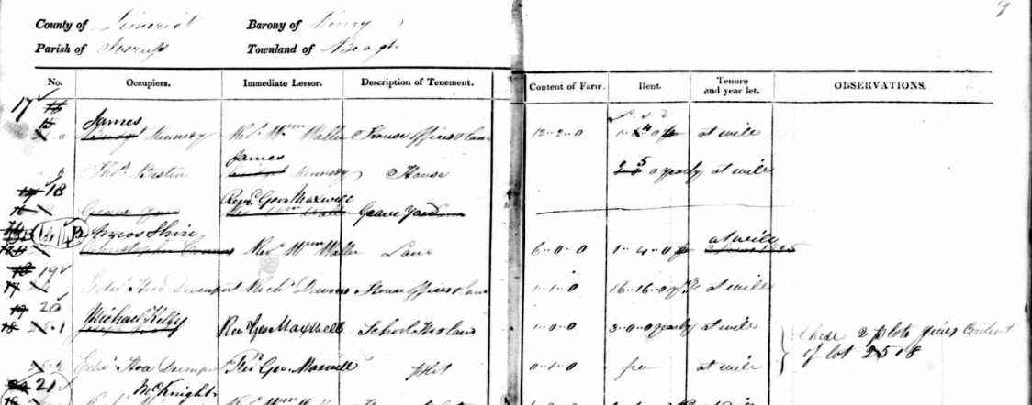
Ireland, Valuation Records, 1824-1856
Name Michael Kelly
Residence Place Iveruss, Beagh, Limerick, Ireland
Residence Barony Kenry
1853 Beagh, Parish of Iveruss
"Divine service is regularly performed in the parochial school, which was erected in 1829, on an acre of land given by J. Waller, Esq., of Castletown, at the expense of the vicar." an excerpt from "A Topographical Dictionary of Ireland," 1837.

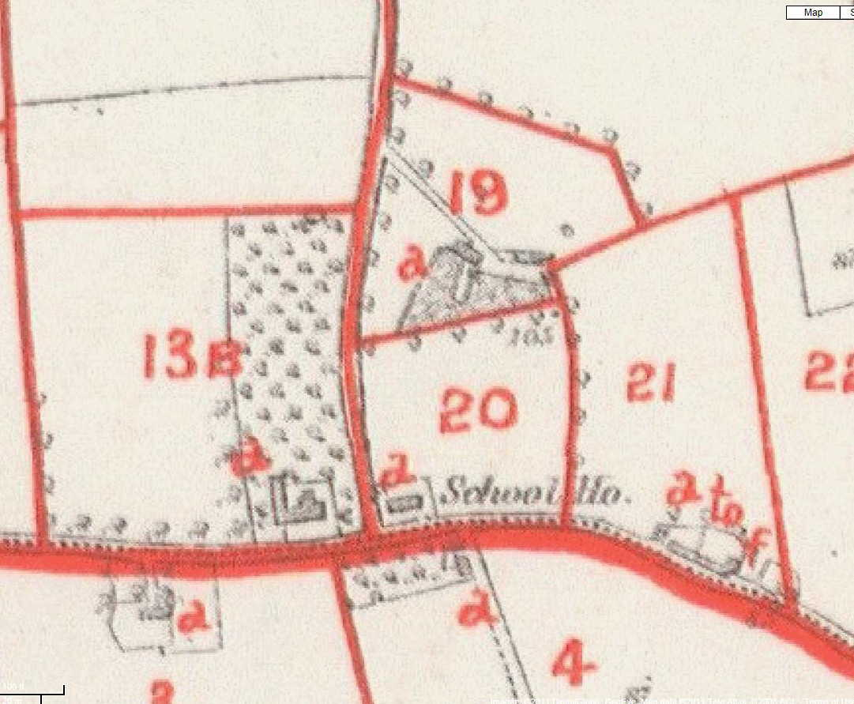
Excerpts from my great-grandfather’s poems:
- My Native Village: “Where the broad Shannon seaward flows…” ” …in a lovely, peaceful valley, where, The noble Shannon smoothly glides.”

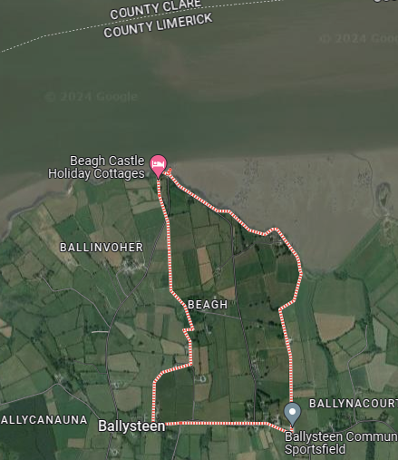
Shannon River WsQA 2q1`1`qqq

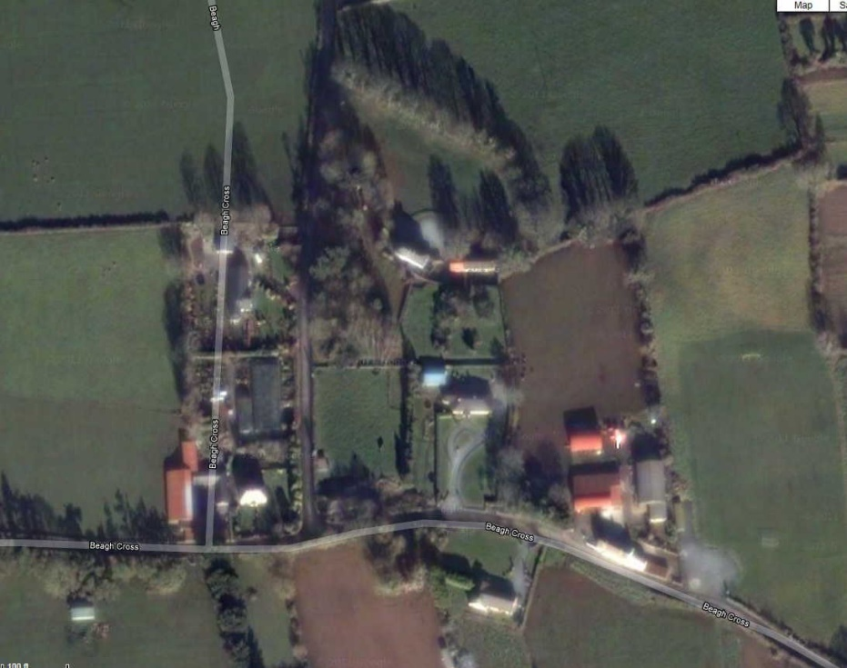
Satellite photo, Beagh Cross Road & Street view of old schoolhouse from Google.



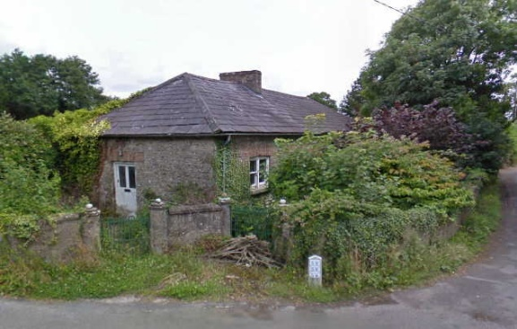
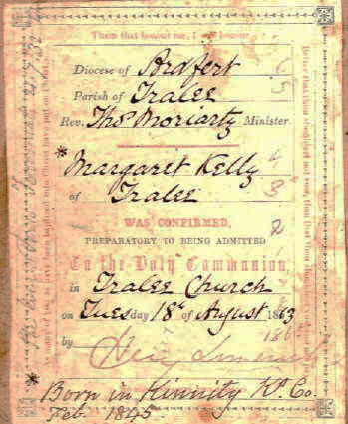
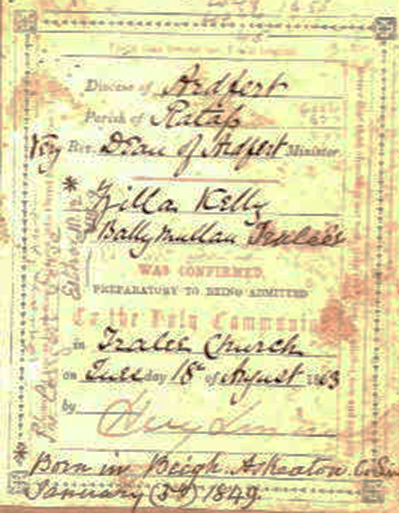
Confirmation certificates of Michael’s daughters, Margaret and Zilla at Tralee Church.*
Residence given as Ballymullan Tralee 1863.

*My father paid for genealogy research a couple times in the 1980’s with no significant results. (I have found a lot more since then!) One report said that “The Rev. Thomas Moriarty who confirmed Margaret and Zilla Kelly was rector of Tralee from 1862-1869. He was a very interesting character, a convert from Catholicism, as was Michael Brett Kelly, and a great innovator in the Church of Ireland by his use of Irish in preaching.”
A family story claims that Michael was studying for the priesthood when he met and married his wife…but I am skeptical of that story…All my research indicates that he seems to have been deeply involved with the Church of Ireland from at least the time of his marriage, having been employed at a parish schoolhouse.
All 3 of his children in the U.S. appear to have converted back to Catholicism. (Marriage and Cemetery records). My great grandfather, Andrew, married his 3rd wife, my great grandmother, however, in a civil ceremony; she attended a Presbyterian Church. Family stories indicate that my grandfather was likely raised Catholic but appears to have left home and the church when he was 15.
...I can find no cemetery record or other record that indicates whether Michael converted back to Catholicism.

Immigration to the United States between 1867 to 1869.
I have been unable to find any passenger records for the entire family. It is likely that they came over separately. A previous correspondence speculated that perhaps Michael lost his job due to the disestablishment of the church. His son, in his poetry “Fugitive Pieces,” often speaks of himself as an Exile. One poem is titled “An Exile’s Farewell” https://danasgenealogy.com/wp-content/uploads/2015/11/Fugitive-Pieces-by-A-A-Kelley.pdf
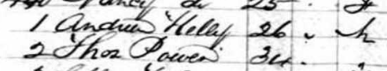
- Margaret may have been the 1st with a marriage record in Clinton. Iowa on 7 Jan 1867, even though the 1900 census says she immigrated in 1869.
- My great grandfather, Andrew, was supposed to have been 16 at the time of his immigration. My father found a passenger record at right and thought maybe he lied about his age? Naturalization records confirm 1867 as his year of arrival.
Departure Port Liverpool, England and Queenstown, Ireland
Destination USA
Arrival Date 4 Dec 1867
Arrival Port New York, New York, USA
Ship Name France
Next to Andrew is a Thos. Power--a James Powers gave an oath for his, Andrew's, naturalization--possibly related?
- The notation in Michael Kelly’s Bible suggests he is in Clinton by 1868.
- The 1900 census says that Zillah immigrated in 1869, but these dates are often inaccurate, as shown above!
It is unclear where Michael may have taught school in Clinton, Iowa. But his son’s obituary says that his son “…attended the public schools, graduating from Clinton high school with honors.”
Residences in Clinton, Iowa:
1870 City Directory Clinton, Iowa
1883 City Directory, Clinton, Iowa
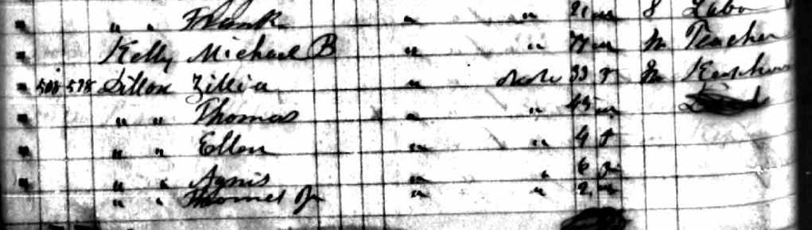
Iowa, U.S., State Census Collection 1885, Clinton, Enumerated below him is his daughter Zillah Dillon and her family.
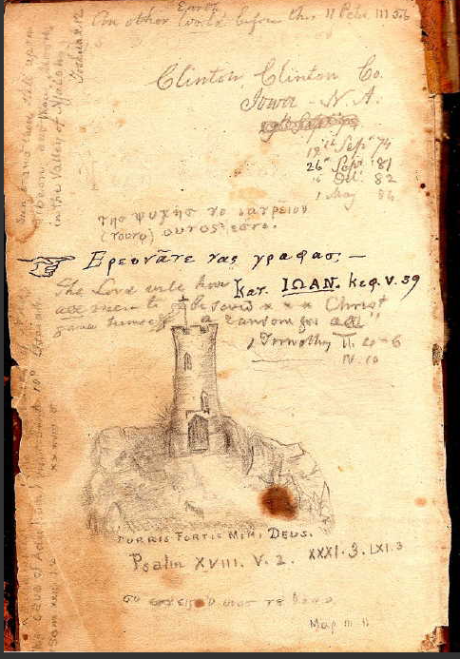
Notations made in Michael B. Kelly’s Bible
My dad had someone try to translate some of the Greek. That person came up with the phrase below. I tried with Google translate to do the one above and came up with: τησ ψυχης γω νατρείοω (τουτο) oυτος εστε = of the soul I nourish (this) this is you

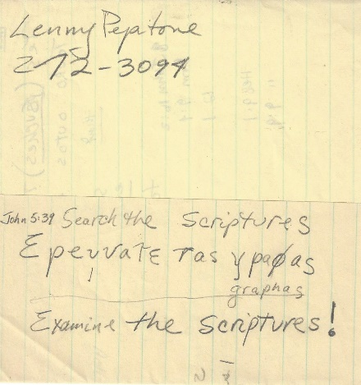
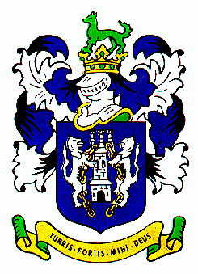

Michael made several notations in his bible from 1868 to the time of his death in 1885. Included was this hand drawn sketch of a tower with the Kelly motto written below it.

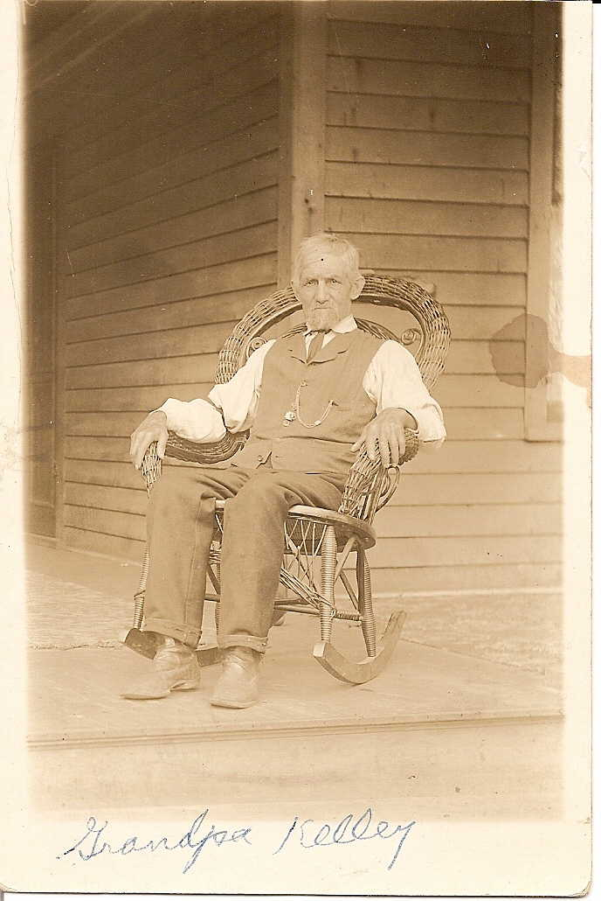
Michael Britt Kelly (1808-1885)

Death 11 Aug 1885, Clinton, Iowa
Iowa, U.S., Death Records, 1880-1972

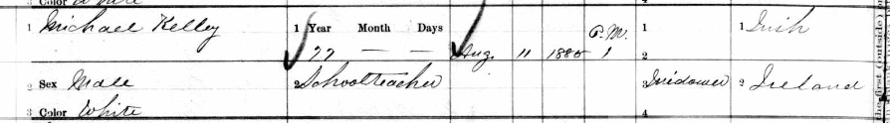
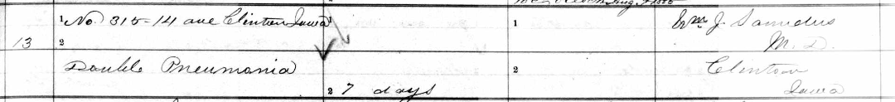
DNA & ethnicity
My dad’s grandparents all immigrated from Europe. His grandfather, Andrew Alfred Kelley, from Ireland (1867), his paternal grandmother from East Friesland in Germany (1868) and his maternal grandparents from Schleswig-Holstein in Germany (1883 & 1884). Unfortunately, I did not get my dad DNA tested before his death. Myself, 2 of my brothers, and many other close relatives have tested.
On my Kelley/Kelly side, I have DNA matches with several relatives in the 1st, 2nd and ½ 2nd cousin range. I also have several 3rd cousin matches (or matches with their descendants) who descend from my great grandfather’s sister, Margaret. My brothers match with a biological descendant of his sister, Zillah.
I keep hoping to confirm some matches more distant. But I do not know if Michael Britt Kelly had any siblings. My only hint is a poem that has T. Kelly at the bottom (in a different handwriting); the poem mentions a little sister and a brother. Is he possibly Andrew’s uncle, or is this poem fiction? That poem and other poems (in pdf files) written by my great grandfather, Andrew Alfred Kelley, can be found on my website: https://danasgenealogy.com/category/poems/
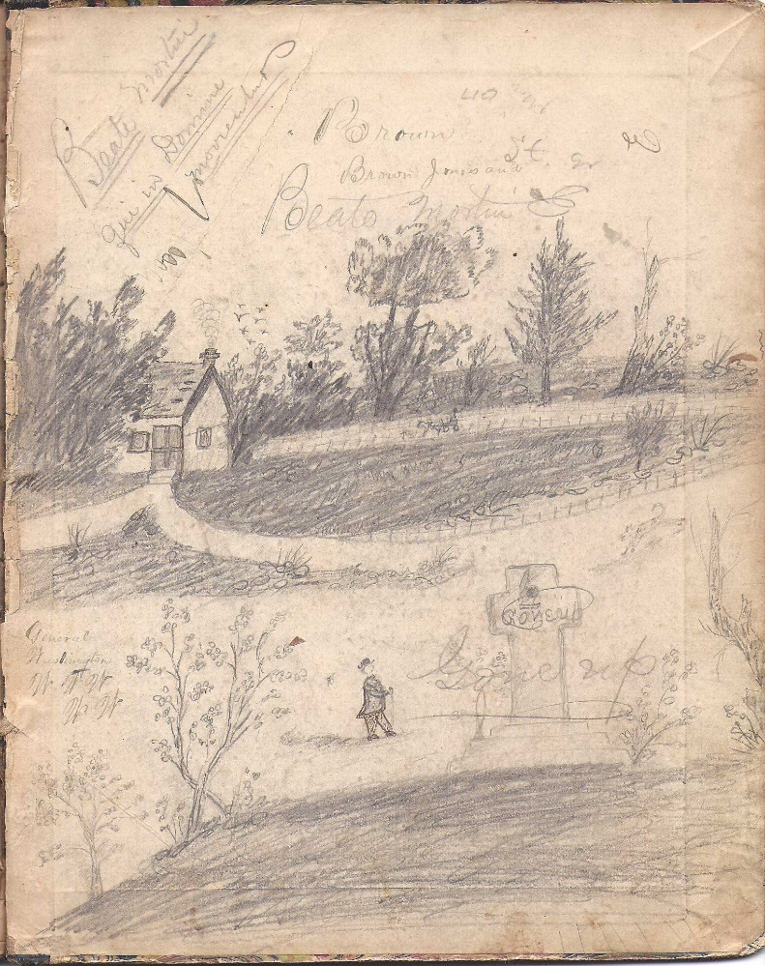
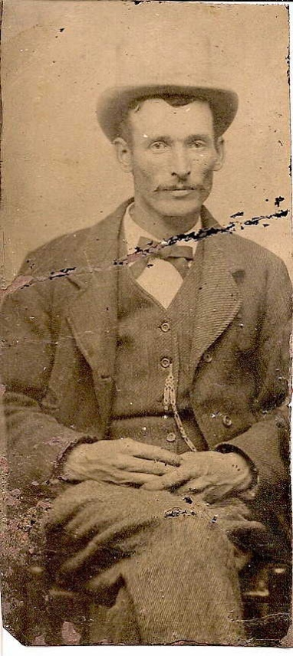

My great-grandfather,
Andrew Alfred Kelley*
He added the “e” to Kelly, soon after immigrating to the U.S.

Back fly leaf of Fugitive Pieces
Even though, my great grandfather was from Ireland, ethnicity estimates from different DNA companies show us as having very little, if any, Irish. If he were fully Irish, we would expect that my brothers and I would each have ~12.5% Irish. Instead, AncestryDNA gives me 0% Irish, but 11% Scottish paternal DNA, but they give my brothers 2-4% Irish and no Scottish paternal DNA. (Looking at how Ancestry breaks down ethnicities at the chromosome level…there are clearly some conflicts…where I know I share segments with my brothers, we are given different ethnicities for some of those segments.)
LivingDNA, on the other hand, gives me a total of 9.2% Irish, my mom 4.9%, my brothers, 5.7% & 2.4%...So that company has me with more Irish. LivingDNA also shows either my brothers or me having connections to S. Central England, NW England, Cumbria, Northumbria, Aberdeenshire, and Orkney & Shetland Islands that my mom does not have. We also have more S. England, SE England, Central England, East Anglia, & Lincolnshire than she did. But our connection to those areas is likely due to the relationship between my Schleswig-Holstein and Frisian ancestors to those populations.
Angles (tribe) from Wikipedia
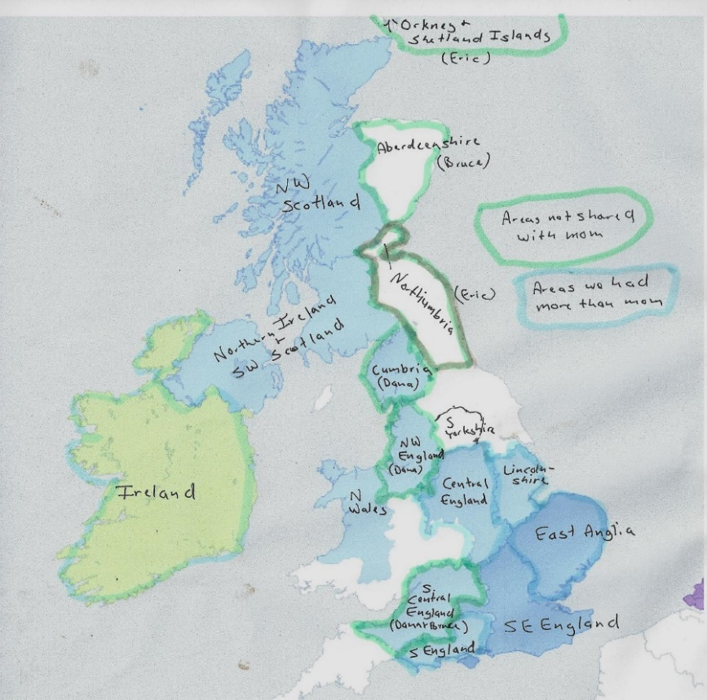
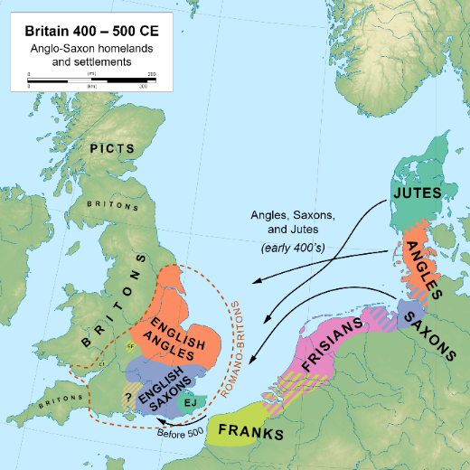
LivingDNA regions comparison with mom.
I have speculated that since McKettrick appears to be Scottish* in origin, and Britt, means Breton, that would suggest ancestry from those Celtic regions. I have recently been learning more about Normans (Hiberno-Normans) and English (Anglo-Irish) in Ireland, too. We have paternal Norwegian, which could indicate Viking, (if any, comes from our Kelly side, but it appears that much of the Norwegian comes from our Frisian side.)
*”The steady movement of peoples back and forth between Scotland and Ireland had been a common occurrence since well before recorded history.” From History of the Scots and Scots-Irish, https://ruralhill.net/heritage/
I found in my brothers’ paternal matches, a woman who descends from a Thomas McKitterick (b. 1819) from Manchester, England. That is the only match I have been able to find with any name similar to McKettrick on our paternal sides.
I have also had a Kelley nephew and ½ 2nd cousin do yDNA tests. We have been assigned haplogroup R-FT201265. Our Kellys are more closely related to the O’Briens (Irish Type III) than the Ui Maine Kellys (a different branch from L21, DF13; other DF13 Kellys in the Kelly surname project are grouped with: Nial Kellys, Seven Septs of Laois, Southern Irish, and Big Scots.).
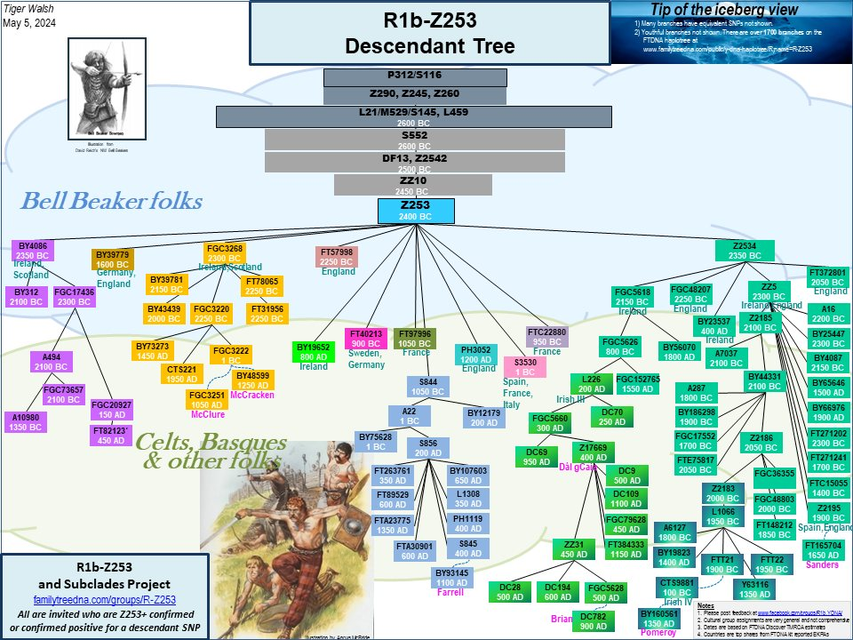
Our Kelley/Kelly Branch
Our closest yDNA matches are mostly all Kelly/Kelleys. Most, if not all, appear to descend from David O’Killia, an Irishman who immigrated to the Massachusetts Colony in the mid 1600’s. Our most recent common ancestor with these matches must be at least 12 generations back, given that my ancestors immigrated in the late 1860’s.
I had assumed that due to our close relationship to the O’Briens that it is very likely that we descend from Brian Boru, too. I just discovered that the Bruces of Scotland also descend from Brian Boru!—who I believe we descend from on my mom’s Scots-Irish side!

Given Names
I have also speculated about the given names in the family. The Andrews, Alfred, David and Margaret, especially, appear to be more Scottish, English or Welsh than Irish. Zillah appears to be a name from the Old Testament.
*”Surnames used as a middle name [Michael Britt Kelly] were the reserve of the gentry in Ireland. Protestant and Catholic cess-payers used middle names as a vehicle for the preservation of a mother’s maiden name when it held some prestige or inheritance.”
Irish Naming Patterns
Irish Naming Traditions for Boys
- 1st son named after the paternal grandfather (his father's father); [Andrew---but where did his middle name Alfred come from?]
- 2nd son after the maternal grandfather (his mother's father);
- 3rd son after his father;
- 4th son after his eldest paternal uncle (his father's eldest brother) and so on in that order.
Irish Naming Traditions for Girls
- ​NOTE: this wasn’t always followed as closely as it was for boys
- 1st daughter named after the maternal grandmother (her mother's mother); [Margaret was her paternal grandmother’s name; maybe the maternal grandmother had the same name or was unknown given that her mother might have been an orphan?]
- 2nd daughter after the paternal grandmother (her father's mother); [Zillah H? any significance?]
- 3rd daughter after her mother; [Marian, a version of Mary]
- 4th daughter after her mother's eldest sister; and so on in that order.
This is copied from:
https://www.irelandxo.com/ireland-xo/news/irish-naming-conventions-and-baptism-traditions
They also list are examples pertaining to the Reliability and Exceptions to the Naming Patterns

*Names of Michael Britt Kelly’s grandchildren:
Children of Margaret & James Donahue:
Honora Anna “Nan” Donahue
Mary “Mayme” Donahue
James Donahue
Children of Margaret & Patrick Walsh
Ellen “Nelle” Walsh
Katherine Walsh
Agnes Margaret Walsh
Winifred B Walsh
Alice Walsh
John Robert Walsh (died young)
Children of Zillah:
Agnes Mary Dillon
Ellen Zillah Dillon
Thomas P. Dillon
Child of Andrew & Ellen Savage:
Alfred James Kelley
Children of Andrew & Kate O’Brien
Eddie Kelley (died young)
John Gerald Kelley
Children of Andrew & Ida Auen:
Mary Ellen “Mayme Kelley
Eilert Walden “Ike” Kelley (named for his maternal grandfather.)
Willam Walter Kelley (my grandfather)
Roy Owen Kelley
Edwin Britt “Pat” Kelley
George Bruce Kelley

*Margaret & Zillah both married Irishmen. Andrew’s 1st 2 wives were Irish.---There are no Michaels or Andrews-- but then there were a lot of girls! I don’t know if my grandfather continued to be estranged from his father…He did continue to see his mother after he left home.

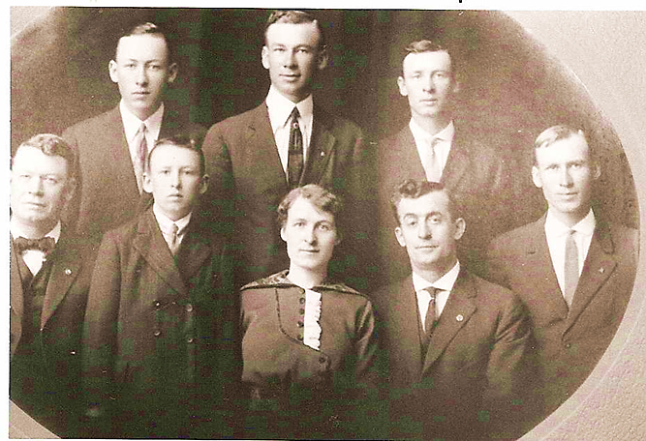
Children of Andrew Alfred Kelley: Top: Edwin Britt "Pat," Eilert Walden "Ike," Owen Roe "Roy;" Bottom: Alfred James, George Bruce, Mary Ellen "Mayme," John Gerald, William Walter "Bill."

